Biology- Class XI

MINERAL NUTRITION- CHAPTER 12

EXEMPLAR QUESTIONS

VERY SHORT ANSWER TYPE QUESTIONS

1. Name a plant, which accumulate silicon.

Answer- *Triticum aestivum* (common wheat); *Oryza sativa* (Asian rice). [Silicon has been found to be beneficial in stress conditions and it delays wilting in drought conditions.]

2. Mycorrhiza is a mutualistic association. How do the organisms involved in this association benefit from each other?

Answer- Mycorrhiza is an association between higher plants and fungi. In this, the fungi help the plant in absorption of mineral nutrients from the soil while the plants- being autotrophic- provide food to the fungi (a heterotroph) for its survival.

3. Nitrogen fixation is shown by prokaryotes and not by eukaryotes. Comment.

Answer- The process of nitrogen fixation requires a key enzyme- Nitrogenase, which is present only in the prokaryotes. The eukaryotes also lack any counterpart for this enzyme.

4. Carnivorous plants like Nepenthes and Venus fly trap have nutritional adaptations. Which nutrient do they especially obtain and from where?

Answer- Being carnivorous plants, they obtain their nutrition from their prey i.e. the insects. The main nutrient obtained is Nitrogen followed by phosphorous.

5. Name a plant which lacks chlorophyll. How will it obtain nutrition?

Answer- Examples of plants that lack chlorophyll- Cuscuta and Monotrapa. They obtain nutrition through a parasitic mode of existence with another autotrophic plant.

6. Name an insectivorous angiosperm.

Answer- Ultricularia is an insectivorous angiosperm.

7. A farmer adds Azotobacter culture to soil before sowing maize. Which mineral element is being replenished?

Answer- Azotobacter is a Nitrogen fixing bacteria and so it replenishes nitrogenous compounds in the soil.

8. What is the function of leghaemoglobin in the root nodule of a legume?

Answer- Leghaemoglobin is a pink coloured pigment which is an oxygen scavenger that protects another important enzyme- Nitrogenase’s function by providing it an anaerobic environment.

9. What is common to Nepenthes, Utricularia and Drosera with regard to mode of nutrition?

Answer- All these plants are insectivorous and they trap insects from which they derive their nutrition.

10. Plants with zinc deficiency show reduced biosynthesis of _______________.

Answer- Auxin

11. Yellowish edges appear in leaves deficient in __________________ mineral.

Answer- N, K, Mg, S, Fe, Mn, Zn and Mo. [Page 199, NCERT 2021-22]

12. Name the macronutrient which is a component of all organic compounds but is not obtained from soil.

Answer- Carbon

13. Name one non-symbiotic nitrogen fixing prokaryote.

Answer- Azotobacter

14. Rice fields produce an important greenhouse gas. Name it.

Answer- Methane (CH4). The paddy fields have high amount of water in the soil which makes the condition anaerobic, wherein, the bacteria produce Methane.

15. Complete the equation for reductive amination

___?___ + NH4 + + NADPH 🡪 glutamate + H2O + NADP

Answer- Alpha ketogluteric acid

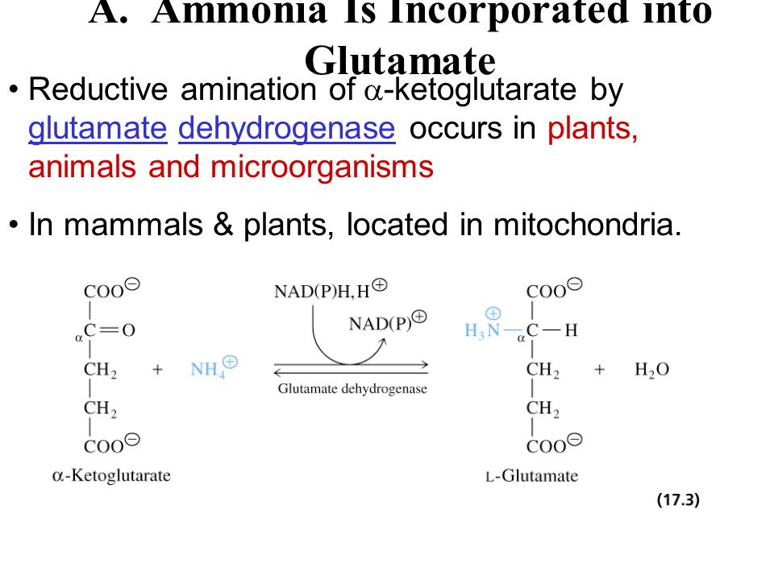

16. Excess of Mn in soil leads to defeciency of Ca, Mg and Fe. Explain.Answer- Manganese competes with iron and magnesium for uptake and with magnesium for binding with enzymes. It also inhibits calcium translocation in shoot apex. [Page 199, section 12.2.4; NCERT 2021-22]